Region 19: Boston-Worchester-Manchester, MA-NH CSA

- Geographic Boundaries, Political Jurisdictions and Infrastructure

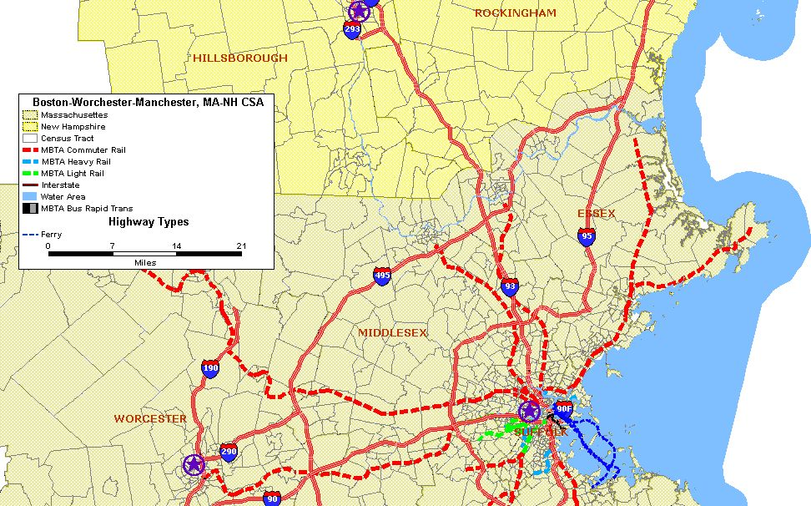
Boston, MA

Worcester, MA
Manchester, NH
Map 19.1: Boston-Worchester-Manchester, MA-NH CSA Major Highways and Fixed Guideway System
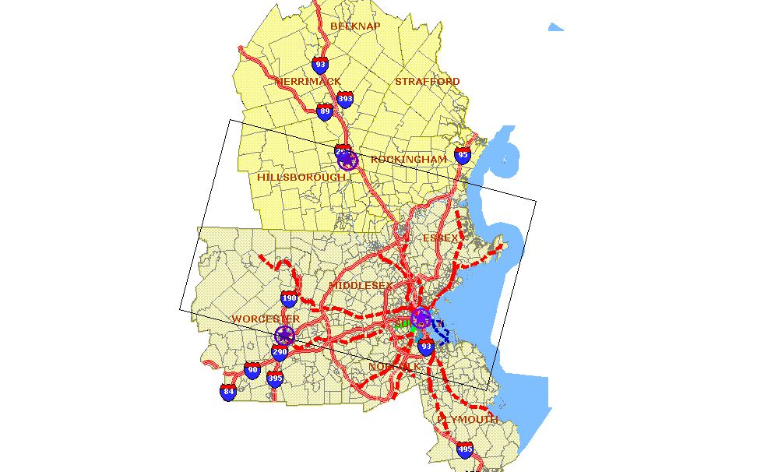
Area of Detail

The Boston-Worchester-Manchester, MA-NH CSA is comprised of six counties in Massachusetts and five counties in New Hampshire. The major urban areas that are within the CSA include the cities of Manchester, NH in Hillsborough County; Worchester, MA in Worchester County; Boston, MA in Suffolk County; and Cambridge, MA in Middlesex County. The area is located in the northern portion of the United States with the Atlantic Ocean bordering the both states to the East. The CSA is approximately 7,497 square miles with a population of 5.7 million persons. The 2000 bi-state population was 7,657,924, as follows: Massachusetts – 6,398,743; and New Hampshire – 1,259,181.

The region is served by a number of interstate highways, fixed guideway, ferry and bus routes. The major east-west highways include Interstates 89, 90, 290 and 393; and the major north-south highways include Interstates 84, 93, 95, 190, 195, 293, 395 and 495.

The Charles River Basin defines the center of Boston's metropolitan area. The 80-mile long river starts at Echo Lake in Hopkinton and flows through 58 cities and towns in eastern MA before emptying into Boston Harbor. It separates Boston proper from Cambridge, Watertown, and the neighborhood of Charlestown. Further north is the Merrimack River. The river is 110 miles long rising from the confluence of the Pemigewasset and Winnipesaukee rivers in Franklin, New Hampshire, flowing southward into Massachusetts, and then northeast, near the Massachusetts-New Hampshire border, until it empties into the Atlantic Ocean at Newburyport.

The region’s climate is continental in which seasonal temperatures vary greatly from one season to the next. Summers are typically warm and humid, while winters are cold, windy and snowy. Massachusetts' geographic location jutting out into the North Atlantic also makes the area very prone to Nor'easter weather systems that can dump more than 20 in (50 cm) of snow on the region in one storm event.
- Agencies Operating in the Boston-Worchester-Manchester, MA-NH CSA

Agency | Jurisdictions Served | Population Served | Operating Budget | Staff Size
Massachusetts DOT | Worcester, Middlesex, Norfolk, Suffolk, Plymouth, Essex counties | 6,398,743 | (a) | (a)
New Hampshire DOT | Hillsborough, Merrimack, Belknap, Rockingham, Strafford counties | 1,259,181 | (a) | (a)
Boston Metropolitan Planning Organization | Middlesex, Norfolk, Suffolk, Plymouth, Essex and Worcester counties | 3,066,321 | (a) | 61
Central Massachusetts Regional Planning Commission | Worcester county | 518,481 | (a) | (a)
Merrimack Valley Planning Commission | Essex county | 318,556 | (a) | 14
Southern New Hampshire Planning Commission | Hillsborough, Merrimack, Rockingham | 248,834 | (a) | (a)
Seacoast Metropolitan Planning Commission | Rockingham, Strafford counties | 230,494 | (a) | (a)
Nashua Regional Planning Commission | Rockingham | 195,788 | (a) | (a)
Massachusetts Bay Transportation Authority | Suffolk, Norfolk, Plymouth, Middlesex, Essex counties | 4.6M | (a) | (a)
Worcester Regional Transit Authority | City of Worchester and Boylston, West Boylston, Holden, Millbury, Webster, Spencer, Leicester, Auburn, Shrewsbury, Brookfield, East Brookfield, Oxford, and Clinton | 524,725 | $19,000,000 | 11,578
Montachusett Regional Transit Authority | Outside the greater Boston Area in Worcester County | 193,415 | (a) | (a)
Cooperative Alliance for Seacoast Transportation | Seacoast communities of Rockingham and Strafford counties | 94,734 | (a) | (a)
Nashua Transit System | Nashua City, Rockingham county | 80,000 | (a) | (a)
Manchester Transit Authority | City of Manchester, Hillsborough county | 143,500 | (a) | (a)
Greater Laconia Transit Agency | Belknap County | (a) | (a) | (a)
Concord Area Transit | City of Concord, Merrimack County, NH | (a) | (a) | (a)
(a) Not available

Table 19.1: Boston-Worchester-Manchester, MA-NH CSA Transportation Agencies

Transit Service Area: Fixed Guideway and Bus Service Area
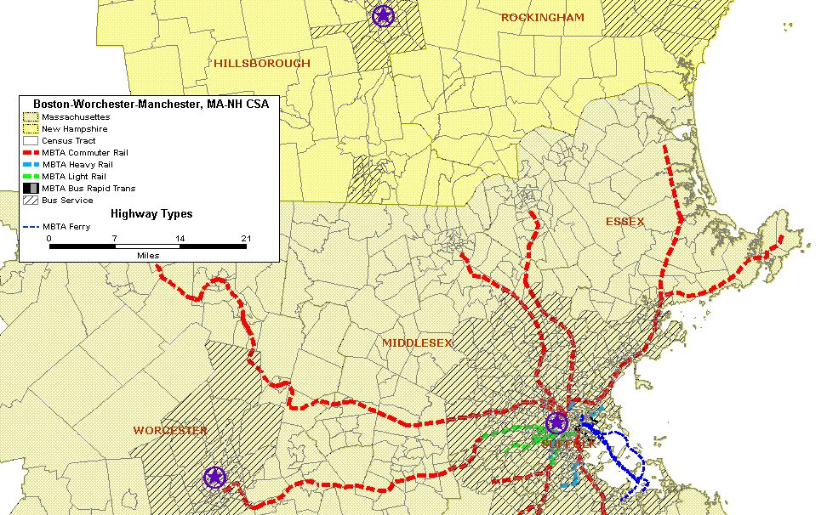
Boston, MA

Worcester, MA
Manchester, NH
Map 19.2: Boston-Worchester-Manchester, MA-NH CSA Fixed Guideway and Bus Transit Service Area

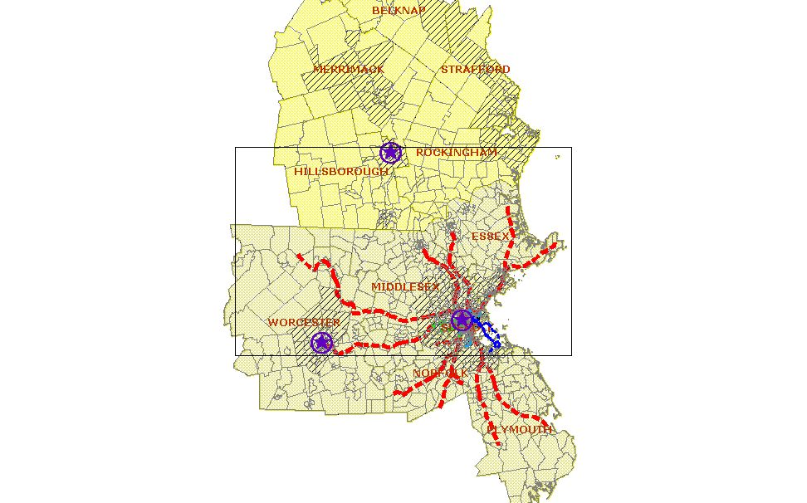

Worcester, MA
Manchester, NH
Boston, MA

The Boston-Worchester-Manchester, MA-NH CSA enjoys a significant level of public transportation service spread over 1,493 square miles. As shown in Map 19.2, the regional network of commuter rail lines is quite extensive. Heavy rail (i.e., Rapid Transit) is operated in the city of Boston and the surrounding metropolitan area. Bus service is provided by a number of agencies and includes a mix of local, commuter and regional bus routes. The following is a brief description of the major transit agencies in the CSA.

  - Massachusetts Bay Transportation Authority (MBTA) – MBTA is the major operator in the area providing extensive service throughout Suffolk county extending to the other five counties in the CSA. MBTA’s service can be categorized as follows:
Motorbus: MBTA fixed route motorbus service consists of 197 directly operated routes and 48 routes that are operated under contract either by the MBTA or with jurisdictions that receive subsidies from the MBTA. Peak service is operated with 838 vehicles.
Bus Rapid Transit: MBTA operates four routes with Bus Rapid Transit service known as the Silver Line with 24 vehicles in maximum service.
Heavy Rail: MBTA operates three routes, the Orange, Blue and Red lines, which comprise its heavy rail operation. The heavy rail system covers nearly 38 route miles and includes 53 stations. Peak service is operated with 320 vehicles.
Light Rail: The majority of MBTA's light rail service is operated on the Green Line, which comprises four routes and 70 stations. Additional light rail service is operated on the Mattapan Trolley. In total, MBTA's light rail service includes 26 route miles. Peak service is operated with 393 vehicles.
Commuter Rail: MBTA operates 368 route miles of commuter rail service throughout the Boston Metropolitan area. The commuter rail operation consists of 127 stations and 13 lines. Massachusetts Bay Commuter Rail Company (MBCR) operates all of MBTA’s commuter rail lines under contract. Peak service is operated with 320 vehicles.
Ferry: MBTA operates four ferry routes with two commuter boats and two ferries under contract with Water Alternative and Boston Harbor Cruises.

The following table shows FY2005 NTD passenger trips data for each of MBTA’s services:
Mode | Passenger Trips
Motorbus | 134,732,005
Heavy Rail | 142,662,535
Light Rail | 78,088,083
Commuter Rail | 37,898,294
Ferry Boat | 1,298,032
Demand Response | 1,319,818

    - Worcester Regional Transit Authority (WRTA) – WRTA was created in September 1974, pursuant to the provisions of Chapter 161B of the General Laws of the Commonwealth of Massachusetts. The Authority is given general responsibility to develop, finance, and contract for the operation of mass transportation facilities and services within its territory. The WRTA operates 36 routes with 39 of its 49 buses. It annual ridership in FY2004 was 3,791,057.

    - Manchester Transit Authority (MTA) – The MTA was established by the City of Manchester in 1973 to provide mass transit service for the Manchester community. The MTA operates a network of 14 routes with 13 of its 15 buses in peak service. MTA annual ridership approximates 404,599.

A total of five other small to medium sized urban transit systems operate in the Boston-Worchester-Manchester, MA-NH CSA providing bus service to the commuter rail stations and other points of attraction. The small to medium sized transit systems operate with as few as five or up to 30 buses.

- Number and Proportion of Minority, Below Poverty and Limited English Proficient Populations in Relation to the Transit Service Area

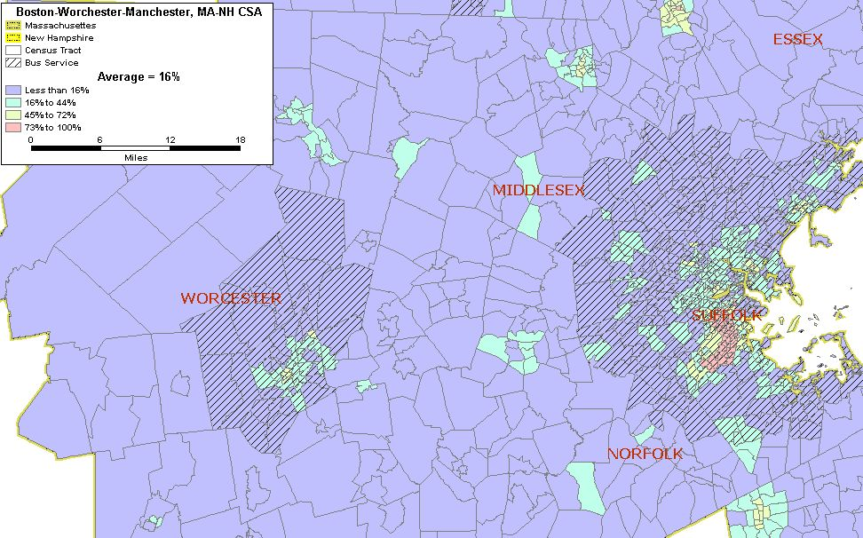
Map 19.3: Boston-Worchester-Manchester, MA-NH CSA Minority Population
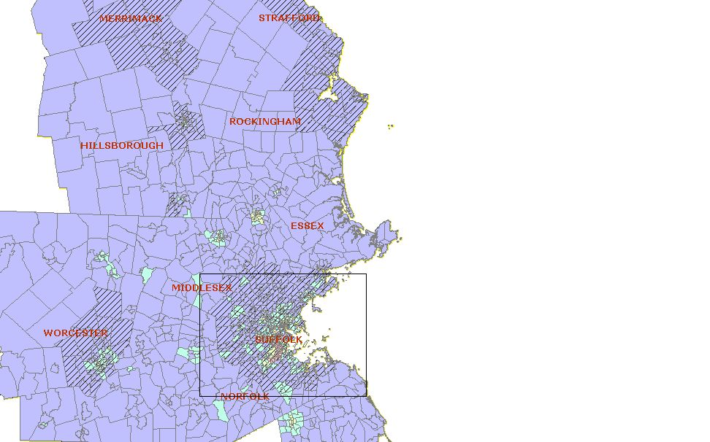
Area of Detail
Boston, MA

Worcester, MA
Manchester, NH
Total Number of Census Tracts in CSA 1,210
Total Population of CSA 5,715,698
Total Minority Population residing in CSA 840,864
Regional Average of Minority Population in the CSA 16%
Number (%) of Census Tracts with above average minority population 370 (31%)
Total Minority Population in the above average census tracts 605,228

According to the U.S. 2000 Census data, the average minority population for the Boston-Worchester-Manchester, MA-NH is 16 percent. Of the 1,210 census tracts in the CSA, 370 or 31 percent have a minority population that exceeds the regional average. As shown in Map 19.3, many of these census tracts are located within the Boston metropolitan area. However, a number of these tracts are also located north of Boston surrounding the city of Worcester, towards the east in Plymouth County and northeast of Boston Manchester, NH. With the exception of one census tract in Essex County, all of the census tracts with the highest percentage (73 percent and above) of minority population are in Boston urbanized area. All but the one tract in Essex County and one Hillsborough County fall within the bus transit service area.

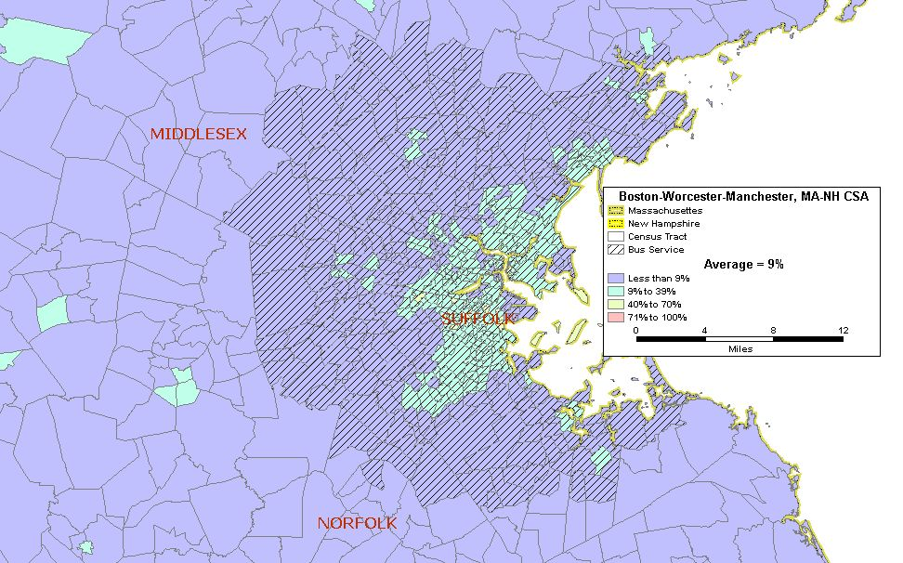
Map 19.4: Boston-Worchester-Manchester, MA-NH CSA Below Poverty Population

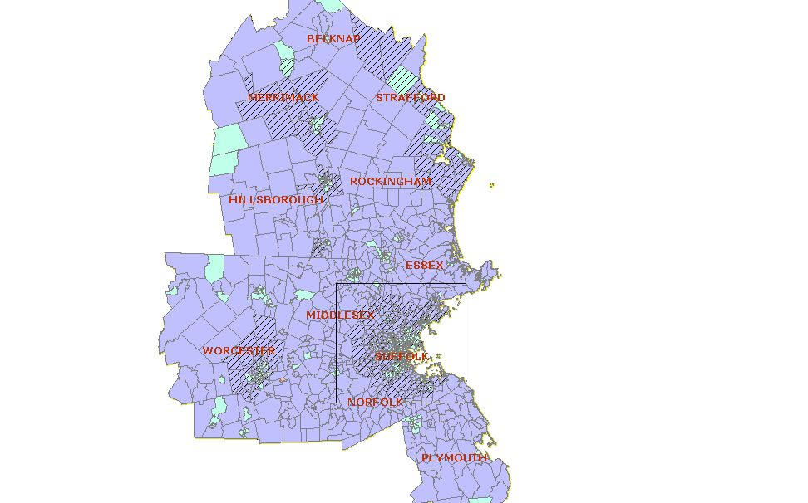
Area of Detail
Boston, MA

Worcester, MA
Manchester, NH
Total Number of Census Tracts in CSA 1,210
Total Population of CSA 5,715,698
Total Below Poverty Population residing in CSA 464,431
Regional Average of Below Poverty Population in the CSA 9%
Number (%) of Census Tracts with above average Below Poverty population 391 (32%)
Total Below Poverty Population in the above average census tracts 293,345

On average, nine percent of the CSA’s population is below the poverty level. Approximately 32 percent (391 census tracts) of the CSA’s census tracts have a below poverty population that exceeds the regional average. The population of below poverty individuals that are in these census tracts is 464,431. As with minority population, the areas in which the below poverty population is concentrated include the Boston metropolitan area. However, unlike the minority population, there are a few census tracts scattered throughout the CSA counties in New Hampshire and Massachusetts in which the below poverty population is between nine and 40 percent. Similar to the minority population, many of these census tracts fall within the bus transit service area.

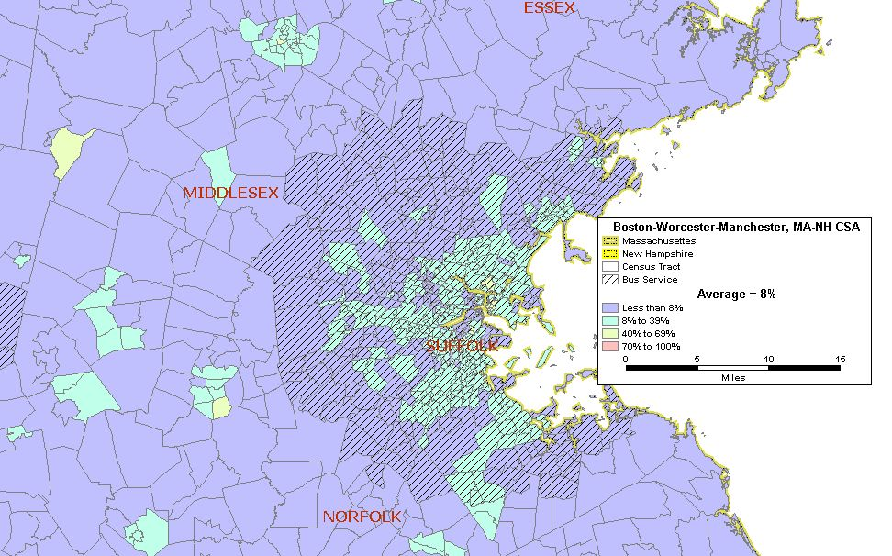
Map 19.5: Boston-Worchester-Manchester, MA-NH CSA Limited English Proficient Population

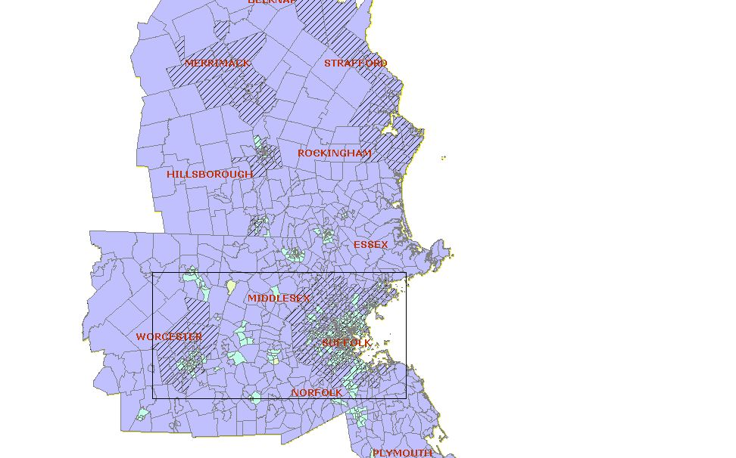
Area of Detail
Boston, MA

Worcester, MA
Manchester, NH
Total Number of Census Tracts in CSA 1,210
Total Population of CSA 5,715,698
Total Population 5 years and older of CSA 5,350,416
Total LEP Population* residing in CSA 387,430
Regional Average of LEP Population* in the CSA 8%
Number (%) of Census Tracts with above average LEP population* 390 (32%)
Total LEP Population* in the above average census tracts 273,698

* LEP includes those 5 years of age and older

There are approximately 387,000 persons in the CSA who are persons with limited English proficiency (LEP). This represents about eight percent of the CSA’s total population. Of the 1,210 census tracts, 390 or 32 percent contain LEP populations that are above the regional average. As shown in Map 19.5, the census tracts with higher than average populations of LEP persons are located within the Boston and Worcester metropolitan areas with some concentrations in Hillsborough County, New Hampshire. Although a fair proportion of these census tracts are within the bus transit service area, many are outside of it.

- Number and Proportion of Zero Car Households: Greater than the Regional Average

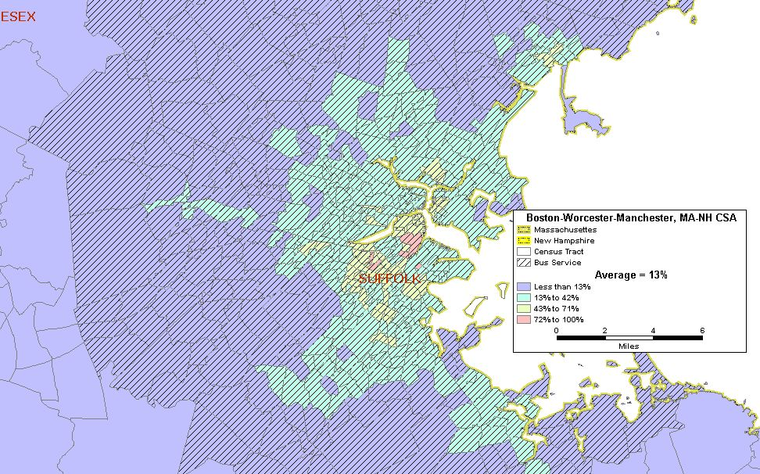
Map 19.6: Boston-Worchester-Manchester, MA-NH CSA Zero Car Households

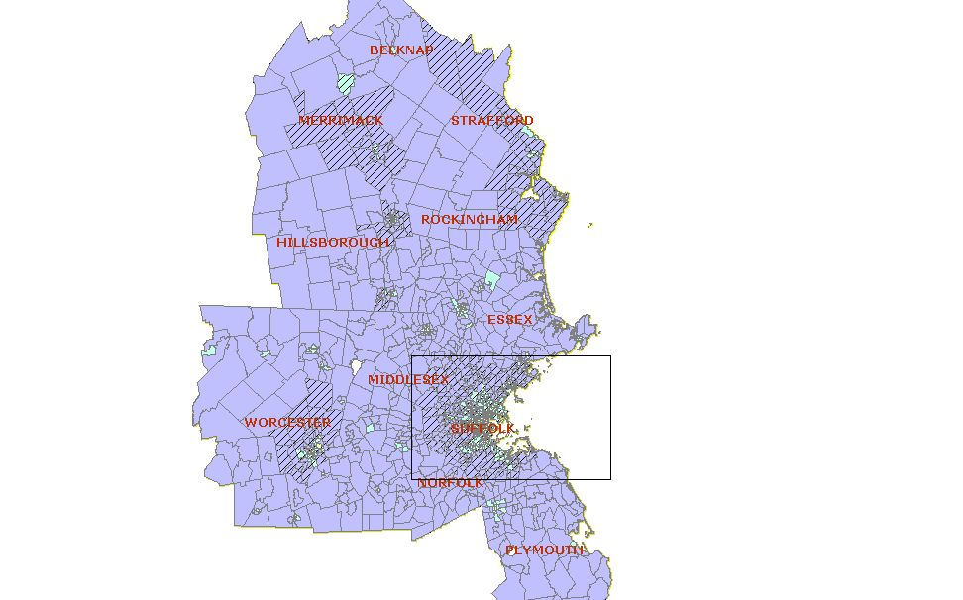
Area of Detail
Boston, MA

Worcester, MA
Manchester, NH

Total Number of Census Tracts in CSA 1,210
Total Households in CSA 2,182,343
Total Zero Car Households in CSA 264,431
Regional Average of Zero Car Households in the CSA 13%
Number (%) of Census Tracts with above average Zero Car HHs 393 (32%)
Total Number of Zero Car Households in the above average census tracts 181,816

A little over one-quarter of a million households in the Boston-Worcester-Manchester CSA do not have access to a vehicle. This represents approximately 36 percent of the total number of households in the CSA. Approximately 32 percent or 393 of the region’s census tracts contain an above average number of households without vehicles. The census tracts that exceed the average are predominantly located in the Suffolk, Norfolk and Middlesex counties in the Boston metropolitan area as shown on Map 19.6. Other pockets of census tracts with higher than average zero car households also are located in Worcester, Massachusetts and Manchester, New Hampshire. As shown in Map 19.6, the vast majority of these households are served by bus transit.
- Number and Proportion of Minority Population with Overlay of Below Poverty Population

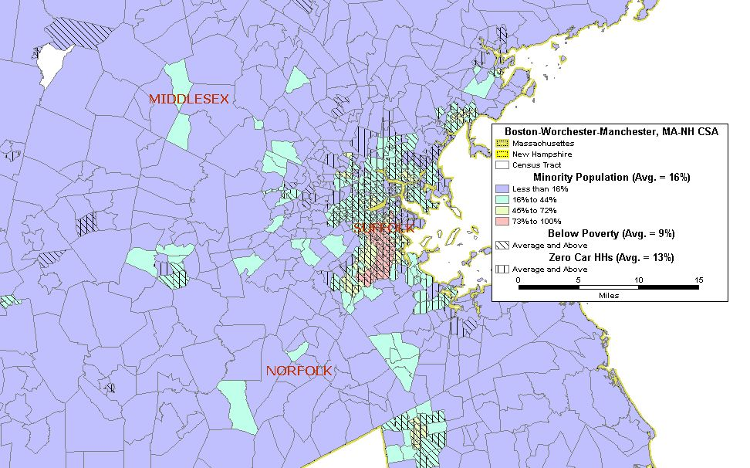
Map 19.7: Boston-Worchester-Manchester, MA-NH CSA Minority Population with an Overlay of Below Poverty Population
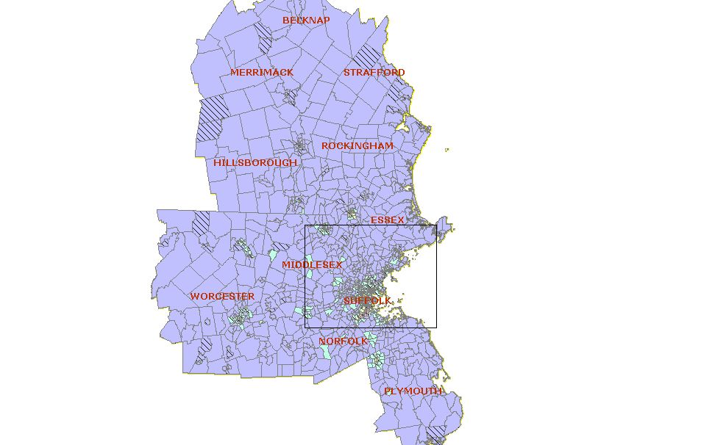
Area of Detail
Boston, MA

Worcester, MA
Manchester, NH

The percentage of minority population is shown overlaid with the percentage of below poverty population in Map 19.7. As shown in this map there are 28 (2.3 percent) census tracts have above average percentages of minority and below poverty populations. This appears to be strongly reflected in the surrounding Boston metropolitan area. Worcester, Plymouth, Middlesex, Norfolk and Rockingham Counties also shows a number of tracts in which there are higher than average populations of both minorities and persons below the poverty level.
- Number and Proportion of Minority Population with Overlays of Below Poverty Population and Zero Car Households

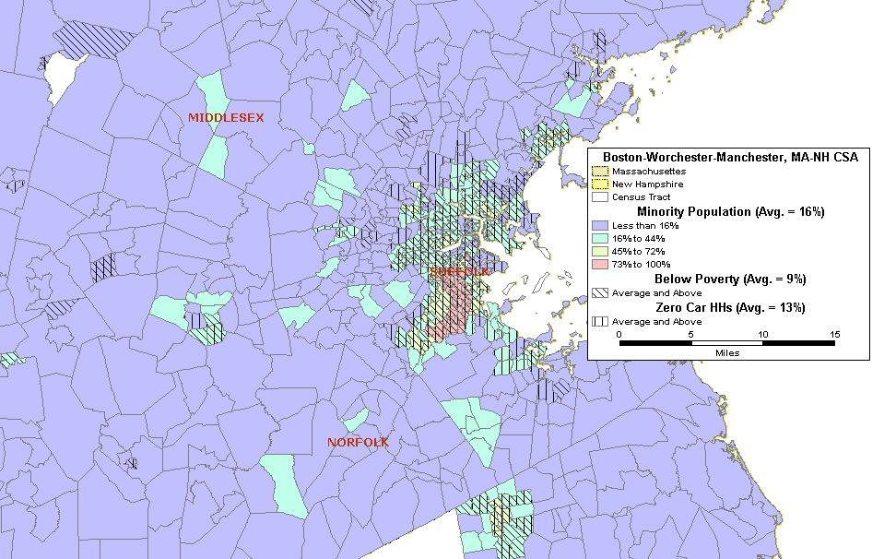
Map 19.8: Boston-Worchester-Manchester, MA-NH CSA Minority Population with Overlays of Below Poverty Population and Zero Car Households
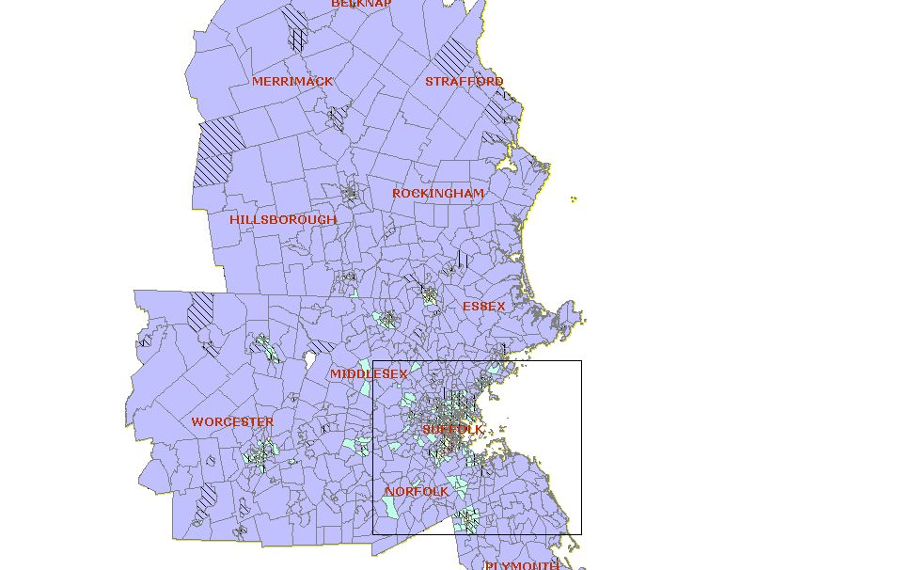
Area of Detail
Boston, MA

Worcester, MA
Manchester, NH

The relationship of minority population, below poverty population and zero car households is shown on Map 19.8. Census tracts in which all three of these statistics exceed the regional averages are primarily located in Boston metropolitan area. Of the 1,210 census tracts in the CSA, 334 census tracts (27.5 percent) have minority populations, below poverty populations and zero car households that exceed the regional average for these statistics.
- Correlation Among Minority Population, Below Poverty Population, LEP Population and Zero Car Households

 | Minority | Below Poverty | LEP | Zero Car HH
Minority | 1.00
Below Poverty | 0.72 | 1.00
LEP | 0.76 | 0.76 | 1.00
Zero Car HH | 0.57 | 0.73 | 0.62 | 1.00

Table 19.2: Boston-Worchester-Manchester, MA-NH CSA Correlation Coefficients

There is a high positive correlation between minority and below poverty populations. As shown in Table 19.2, the coefficient for the relationship between minority and below poverty is 0.72. The table also shows the strongest relationships (coefficient equals 0.76) between the minority and limited English proficient populations and between the below poverty and LEP populations. The below poverty and zero car household population is also higher at 0.73, with the lowest correlations both exceeding 0.50, between minority and Zero Car HH (0.57) and between LEP and Zero Car HH (0.62).

- Natural Disasters

Event(s) | Date | Location | Human Impact | Financial Impact
Heavy Rain and Flooding | June 13-July 6, 1998 | Essex, Middlesex, Norfolk, Plymouth, Suffolk, an Worcester counties in MA; Belknap, Merrimack and Rockingham counties in NH | 2 injuries | $13,425,000
Severe Storms & Flooding | March 5, April 16, 2001 | Essex, Norfolk, Plymouth, Suffolk, Worcester, and Middlesex counties in MA; Hillborough, and Rockingham counties in NH | 0 | $42,160,000
Severe Winter Storm | April 1-30, 2004 | Middlesex, Norfolk, Plymouth, Suffolk and Worcester counties in MA | (a) | (a)
Severe Storms, Flooding, Landslides and Mudslides | October 7-18, 2005 | Middlesex, Norfolk, Plymouth, and Worcester counties in MA; Belknap, Hillsborough and Merrimack counties in NH | 0 | $12,820,000
Severe Storms & Flooding | May 12, 2006 | Essex, Middlesex, and Suffolk counties in MA; Belknap, Hillsborough, Merrimack, Rockingham, and Strafford counties in NH. | 2 deaths | $20,465,000
(a) Not available

Table 19.3: 20-Year History of Natural Disasters in the Boston-Worcester-Manchester CSA (Source: FEMA and NOAA)

The table above presents a snapshot of the naturals disasters that have affected the Boston-Worcester-Manchester CSA during the past 20 years. The main impact of natural disasters is storm-related damage from severe thunderstorms, winter storms, hurricanes/tropical depressions, and tornados. The damage caused by these severe weather events is typically due to flooding and high winds. On a scale ranging from Moderate to High, to Very High Risk, the United States Geological Survey rates the states that comprise this region as having Moderate Risks of earthquakes.

- Man-made Disasters

The primary industries in the states comprising the Boston-Worcester-Manchester CSA region are higher education, research, health care, finance, technology, and biotechnology. In addition the region is home to the Port of Boston. The region also has a number of sites that would be considered high profile targets for terrorism, including many historical and cultural institutions. Three nuclear power plants are also in or in close proximity to the region. As such, there is potential for certain man-made disasters whether by accident or by intention. These include petroleum and chemical leaks or spills, radiological release and industrial sabotage to manufacturing plants, shipping facilities, and infrastructure.

A review of information available through state and federal sources indicated that there was only one man-made disaster in the Boston-Worcester-Manchester CSA over the last 20 years. On October 31, 1999, Egyptair Flight 990 dove into the Atlantic Ocean, about 60 miles south of Nantucket Island, Massachusetts, killing the 14 crew members and 203 passengers on board. An investigation by the NTSB determined that the relief first officer at the controls while the captain was out of the cabin, turned off the autopilot, and deliberately crashed the plane into the ocean. The financial impact was not available. The 2005 data from the U.S. Department of Transportation on Hazardous Material Safety shows the states included in this region (MA, CT, and NH) accounted for three percent of the hazardous materials incidents and three percent of related deaths for the year.

In addition, the region is subject to other man-made disasters as any other major metropolitan area would be. Incidents such as building fires, aircraft accidents and major highway accidents could result in significant number of fatalities and/or casualties as well as property damage.

Due to the scale presented in the MAP leading into this section, the ferry routes are not shown.

